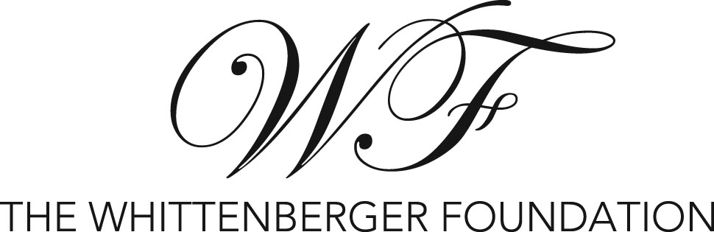

P. O. Box 1073 Caldwell, ID 83606

GRANT APPLICATION 2024

ORGANIZATION_______________________________________Founding Date____________
Employer Identification Number (EIN #)______________________________________________
Mailing Address________________________________________________________________
Web Site______________________________________________________________________

PROJECT CONTACT PERSON____________________________________________________
Contact Title_________________________________Phone_____________________________
E-mail Address_________________________________________________________________

President/CEO of Organization____________________________________________________
E-mail Address______________________________________________Phone______________

Chairperson of Governing Board_____________________________________No. on Board____ E-mail Address______________________________________________Phone______________
List of Board members: __________________________________________________________

PROJECT INFORMATION For Funds Requested:
Total project cost $_______________Amount requested from Whittenberger $_______________
Please circle type of project: Arts Civic Education Social Environmental Recreation

Description and objectives of funding request:

Specifically, how will grant funds be used and who will be served:

Attach project budget. Include amount and sources of contributions/pledges for project to date. List other funding sources from which support is requested.

Project Time Line:

Geographical area to be served by project:

Client group and number to be served by project:

Describe how the success of the project will be evaluated:

ORGANIZATION INFORMATION:
Mission of Organization:

Number of staff: Full time_________Part time_______Number of Volunteers_____________
Tax Exempt Status:
Give organization name on IRS letter, date status granted and classification (501(c)3 or 509 designation). Information will be verified on Guidestar.

______________________________________________________________________

Financial information: (please check one)
____If you filed a Form 990 or 990-EZ it will be reviewed on line.

____If you filed a Form 990-N or did not file, please attach your current balance sheet and income statement with comparative information from one year prior.

____For applying public entities (school districts, state agencies or universities), program specific budget information is sufficient.

Application Forms may not exceed 4 pages. Submit 8 copies of the application and requested documents to the Foundation secretary by AUGUST 15. Applications must be delivered or postmarked by that date. Applications will not be held over to the next year. You will be notified of our decision in early November.

Signature___________________________________________Title_______________________
Printed Name________________________________________________

